Chart Range Functions and

How it works with Chart Inter Record Functions (above() and below())

1. **List of Chart Range Functions**

|  |
| --- |
| RangeSum() |
| RangeAvg() |
| RangeCount() |
| RangeMin() |
| RangeMax() |
| RangeNumericCount() |
| RangeTextCount() |
| RangeNullCount() |
| RangeMissingCount() |
| RangeMinString() |
| RangeMaxString() |
| RangeMode() |
| RangeOnly() |
| RangeCorrel() |
| RangeStdev() |
| RangeSkew() |
| RangeKurtosis() |
| RangeFractile() |

1. **Description of Different Range Functions**
2. **RangeSum()**

Returns the sum of a range of 1 to N arguments. As opposed to the **+** operator, RangeSum will treat all non-numeric values as 0. The argument expressions of this function may contain *Chart Inter Record Functions* with a third optional parameter, which in themselves return a range of values.

Examples:

|  |  |  |
| --- | --- | --- |
| Serial No. | Expression | Output |
| 1 | RangeSum(1,2,4) | 7 |
| 2 | RangeSum(1,’XYZ’) | 1 |
| 3 | RangeSum(NULL()) | 0 |
| 4 | RangeSum(Above(Sum(SalesValue),1,5)) | returns the sum of the five results of the Sum(SalesValue) expression evaluated on the current row on the basis of the five rows above the current row. |

|  |  |  |  |  |  |  |  |  |  |  |  |  |  |  |  |  |  |  |  |  |  |  |  |  |  |  |  |  |  |  |  |
| --- | --- | --- | --- | --- | --- | --- | --- | --- | --- | --- | --- | --- | --- | --- | --- | --- | --- | --- | --- | --- | --- | --- | --- | --- | --- | --- | --- | --- | --- | --- | --- |
|  | 1. **RangeMin()**   Returns the lowest numeric value found within a range 1 to N arguments. If no numeric value is found, NULL is returned.  Examples:   |  |  |  | | --- | --- | --- | | Serial No. | Expression | Output | | 1 | RangeMin(1,2,4) | 1 | | 2 | RangeMin(2,3,6,’XYZ’) | 2 | | 3 | RangeMin(NULL(),’ABC’) | NULL | | 4 | RangeMin(Above(Sum(SalesValue),1,5)) | returns the lowest of the five results of the Sum(SalesValue) expression evaluated on the current row on the basis of the five rows above the current row. |  1. **RangeMax()**   Returns the highest numeric values found within a range of 1 to N arguments. If no numeric value is found, NULL is returned.  Examples:   |  |  |  | | --- | --- | --- | | Serial No. | Expression | Output | | 1 | RangeMax(1,2,4) | 4 | | 2 | RangeMax(2,3,6,’XYZ’) | 6 | | 3 | RangeMax(NULL(),’ABC’) | NULL | | 4 | RangeMax(Above(Sum(SalesValue),1,5)) | returns the highest of the five results of the Sum(SalesValue) expression evaluated on the current row on the basis of the five rows above the current row. | |
|  |  |

1. **RangeAvg()**

Returns the average of a range of 1 to N arguments. If no numeric value is found, NULL is returned. The argument expressions of this function may contain *Chart Inter Record Functions* with a third optional parameter, which in themselves return a range of values.

Examples:

|  |  |  |
| --- | --- | --- |
| Serial No. | Expression | Output |
| 1 | RangeAvg(1,2,4) | 2.33333333 |
| 2 | RangeAvg(1,’XYZ’) | 1 |
| 3 | RangeAvg(NULL(),’ABC’) | NULL |
| 4 | RangeAvg(Above(Sum(SalesValue),1,5)) | returns the average of the five results of the Sum(SalesValue) expression evaluated on the current row and the five rows above the current row. |

Explanation of the last example:

“**Above(Sum(SalesValue),1,5)**” this portion of code inside the RangeAvg() function is creating a range of data and the range is defined by the following method-

When we are in a particular row this code is selecting five rows immediate above the current row.

Now let’s see some snapshots to understand this procedure clearly. In the first row the output will be NULL as there has no other values above it.

**Snap 1:**

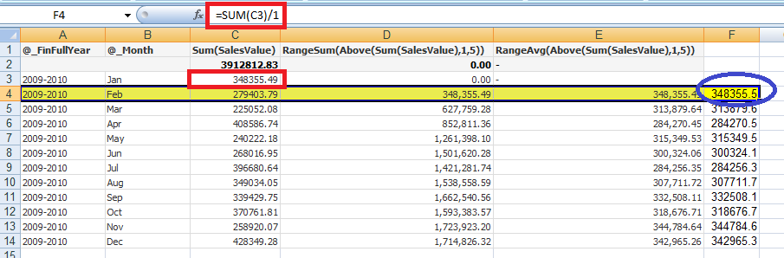

See the BLUE marked portion. As the expression suggest it should take five rows above it but it found only **one** value above the current row (marked with RED under Column C) and that’s why the sum value is divided by **1** only (see the function bar marked with RED).

**Snap2:**

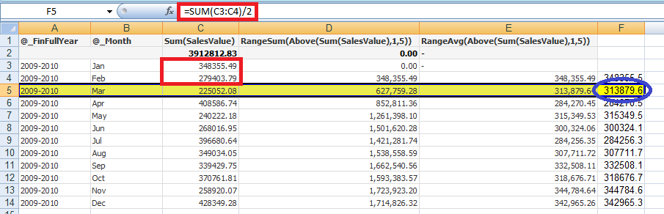

See the BLUE marked portion. As the expression suggest it should take five rows above it but it found only **two** values above the current row (marked with RED under Column C) and that’s why the sum value is divided by **2** only (see the function bar marked with RED).

**Snap 3:**

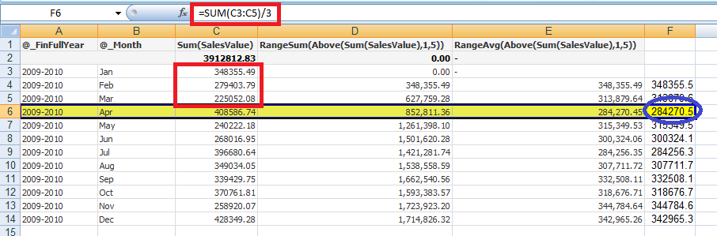

See the BLUE marked portion. As the expression suggest it should take five rows above it but it found only **three** values above the current row (marked with RED under Column C) and that’s why the sum value is divided by **3** only (see the function bar marked with RED).

**Snap 4:**

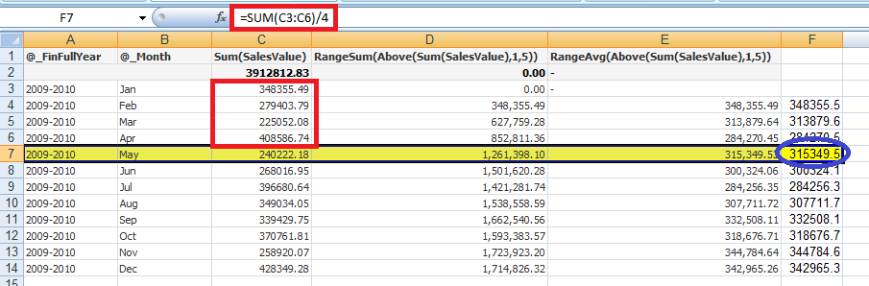

See the BLUE marked portion. As the expression suggest it should take five rows above it but it found only **four** values above the current row (marked with RED under Column C) and that’s why the sum value is divided by **4** only (see the function bar marked with RED).

**Snap 5:**

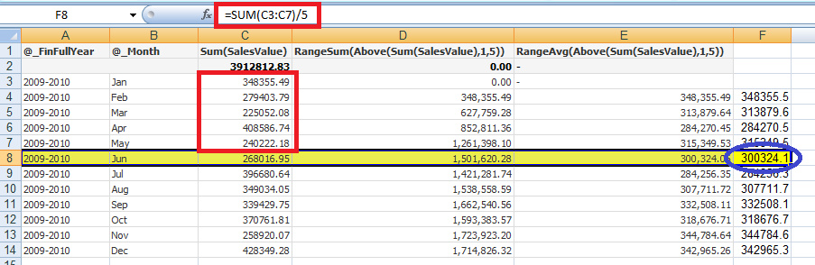

See the BLUE marked portion. As the expression suggest it should take five rows above it and it found **five** values above the current row (marked with RED under Column C) and that’s why the sum value is divided by **5** only (see the function bar marked with RED).

**Snap 6:**

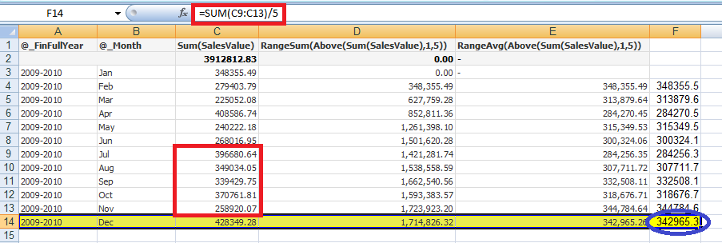

This snap is to show what’s happening for succeeding rows. Here **five** rows immediate above the last row is calculated and eventually the sum value is divided by **5**.

1. **RangeCount()**

RangeCount() function can count both Numeric and String values (both Character string and Alphanumeric values) but not Null values.

Examples:

|  |  |  |
| --- | --- | --- |
| Serial No. | Expression | Output |
| 1 | RangeCount(1,2,4) | 3 |
| 2 | RangeCount(NULL()) | 0 |
| 3 | RangeCount(100,'ABC',Null(),250,'DEF','GHI',Null(),Null(),Null(),'ABC1234','EMP1988','100ABC',999) | 9 |

1. **RangeNumericCount()**

RangeNumericCount() function can count only valid Numeric values but not String values or Null() values.

Examples:

|  |  |  |
| --- | --- | --- |
| Serial No. | Expression | Output |
| 1 | RangeNumericCount(1,2,4) | 3 |
| 2 | RangeNumericCount(NULL()) | 0 |
| 3 | RangeNumericCount(100,'ABC',Null(),250,'DEF','GHI',Null(),Null(),Null(),'ABC1234','EMP1988','100ABC',999) | 3 |

1. **RangeTextCount()**

RangeTextCount() function can count only String values but not Numeric values or Null() values.

Examples:

|  |  |  |
| --- | --- | --- |
| Serial No. | Expression | Output |
| 1 | RangeTextCount(1,2,4) | 0 |
| 2 | RangeTextCount(NULL()) | 0 |
| 3 | RangeTextCount(100,'ABC',Null(),250,'DEF','GHI',Null(),Null(),  Null(),'ABC1234','EMP1988','100ABC',999) | 6 |

1. **RangeNullCount()**

RangeNullCount() function can count only NULL values but not Numeric values or String values.

Examples:

|  |  |  |
| --- | --- | --- |
| Serial No. | Expression | Output |
| 1 | RangeNullCount(1,2,4) | 0 |
| 2 | RangeNullCount(2,'xyz') | 0 |
| 3 | RangeNullCount(100,'ABC',Null(),250,'DEF','GHI',Null(),Null(),  Null(),'ABC1234','EMP1988','100ABC',999) | 4 |

1. **RangeMissingCount()**

RangeMissingCount() function can count Non-Numeric values (i.e. both String and NULL values) but not Numeric values.

Examples:

|  |  |  |
| --- | --- | --- |
| Serial No. | Expression | Output |
| 1 | RangeMissingCount(1,2,4) | 0 |
| 2 | RangeMissingCount(2,'xyz') | 1 |
| 3 | RangeMissingCount(100,'ABC',Null(),250,'DEF','GHI',Null(),Null(),  Null(),'ABC1234','EMP1988','100ABC',999) | 10 |

1. **RangeMinString()**

RangeMinString() function returns the **first value** in text sort order found among 1 to N arguments.

Examples:

|  |  |  |
| --- | --- | --- |
| Serial No. | Expression | Output |
| 1 | RangeMinString(1,2,4) | 1 |
| 2 | RangeMinString('xyz',’DEF’,’abc’) | abc |
| 3 | RangeMinString(100,'ABC',Null(),250,'DEF','GHI',Null(),Null(),  Null(),'ABC1234','EMP1988','100ABC',999) | 100 |

1. **RangeMaxString()**

RangeMaxString() function returns the **last value** in text sort order found among 1 to N arguments.

Examples:

|  |  |  |
| --- | --- | --- |
| Serial No. | Expression | Output |
| 1 | RangeMaxString(1,2,4) | 4 |
| 2 | RangeMaxString('xyz',’DEF’,’abc’) | xyz |
| 3 | RangeMaxString(100,'ABC',Null(),250,'DEF','GHI',Null(),Null(),  Null(),'GHI99','ABC1234','EMP1988','100ABC',999) | GHI99 |

1. **RangeMode()**

RangeMode() function returns the mode value, i.e. the most commonly occurring value within a range of 1 to N arguments. If more than one value shares the highest frequency, NULL is returned.'

Examples:

|  |  |  |
| --- | --- | --- |
| Serial No. | Expression | Output |
| 1 | RangeMode(1,3,4,9,3) | 2 |
| 2 | RangeMode(100,'ABC',Null(),250,'DEF','GHI',Null(),Null(),Null(),'ABC1234','EMP1988','100ABC','DEF') | DEF |
| 3 | RangeMode(100,'ABC',Null(),250,'DEF','GHI',Null(),Null(),Null(),'ABC1234','EMP1988','EMP1988','100ABC',100) | NULL |

1. **RangeOnly()**

If exactly one non-NULL value exists among the range of N expressions, that value will be returned. In all other cases, NULL is returned.

Examples:

|  |  |  |
| --- | --- | --- |
| Serial No. | Expression | Output |
| 1 | RangeMode(5) | 5 |
| 2 | RangeMode(5,6,7) | NULL |
| 3 | RangeMode('abc',Null(),Null(),Null()) | abc |
| 4 | RangeMode('abc',Null(),Null(),Null(),123) | NULL |